What you will learn:

- What does scientific research say about the use of marijuana by our youth?
- What resources are available to educate our youth about marijuana and its (mis)use?
- How does marijuana impact the brain?
- HH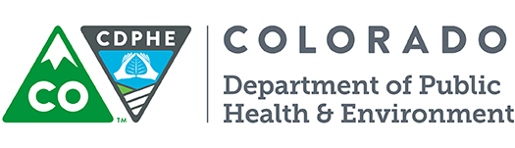Retail Marijuana Education Program

P: 303.692.6435 | 4300 Cherry Creek Drive South, Denver, CO 80246
erin.flynn@state.co.us | www.colorado.gov/cdphe
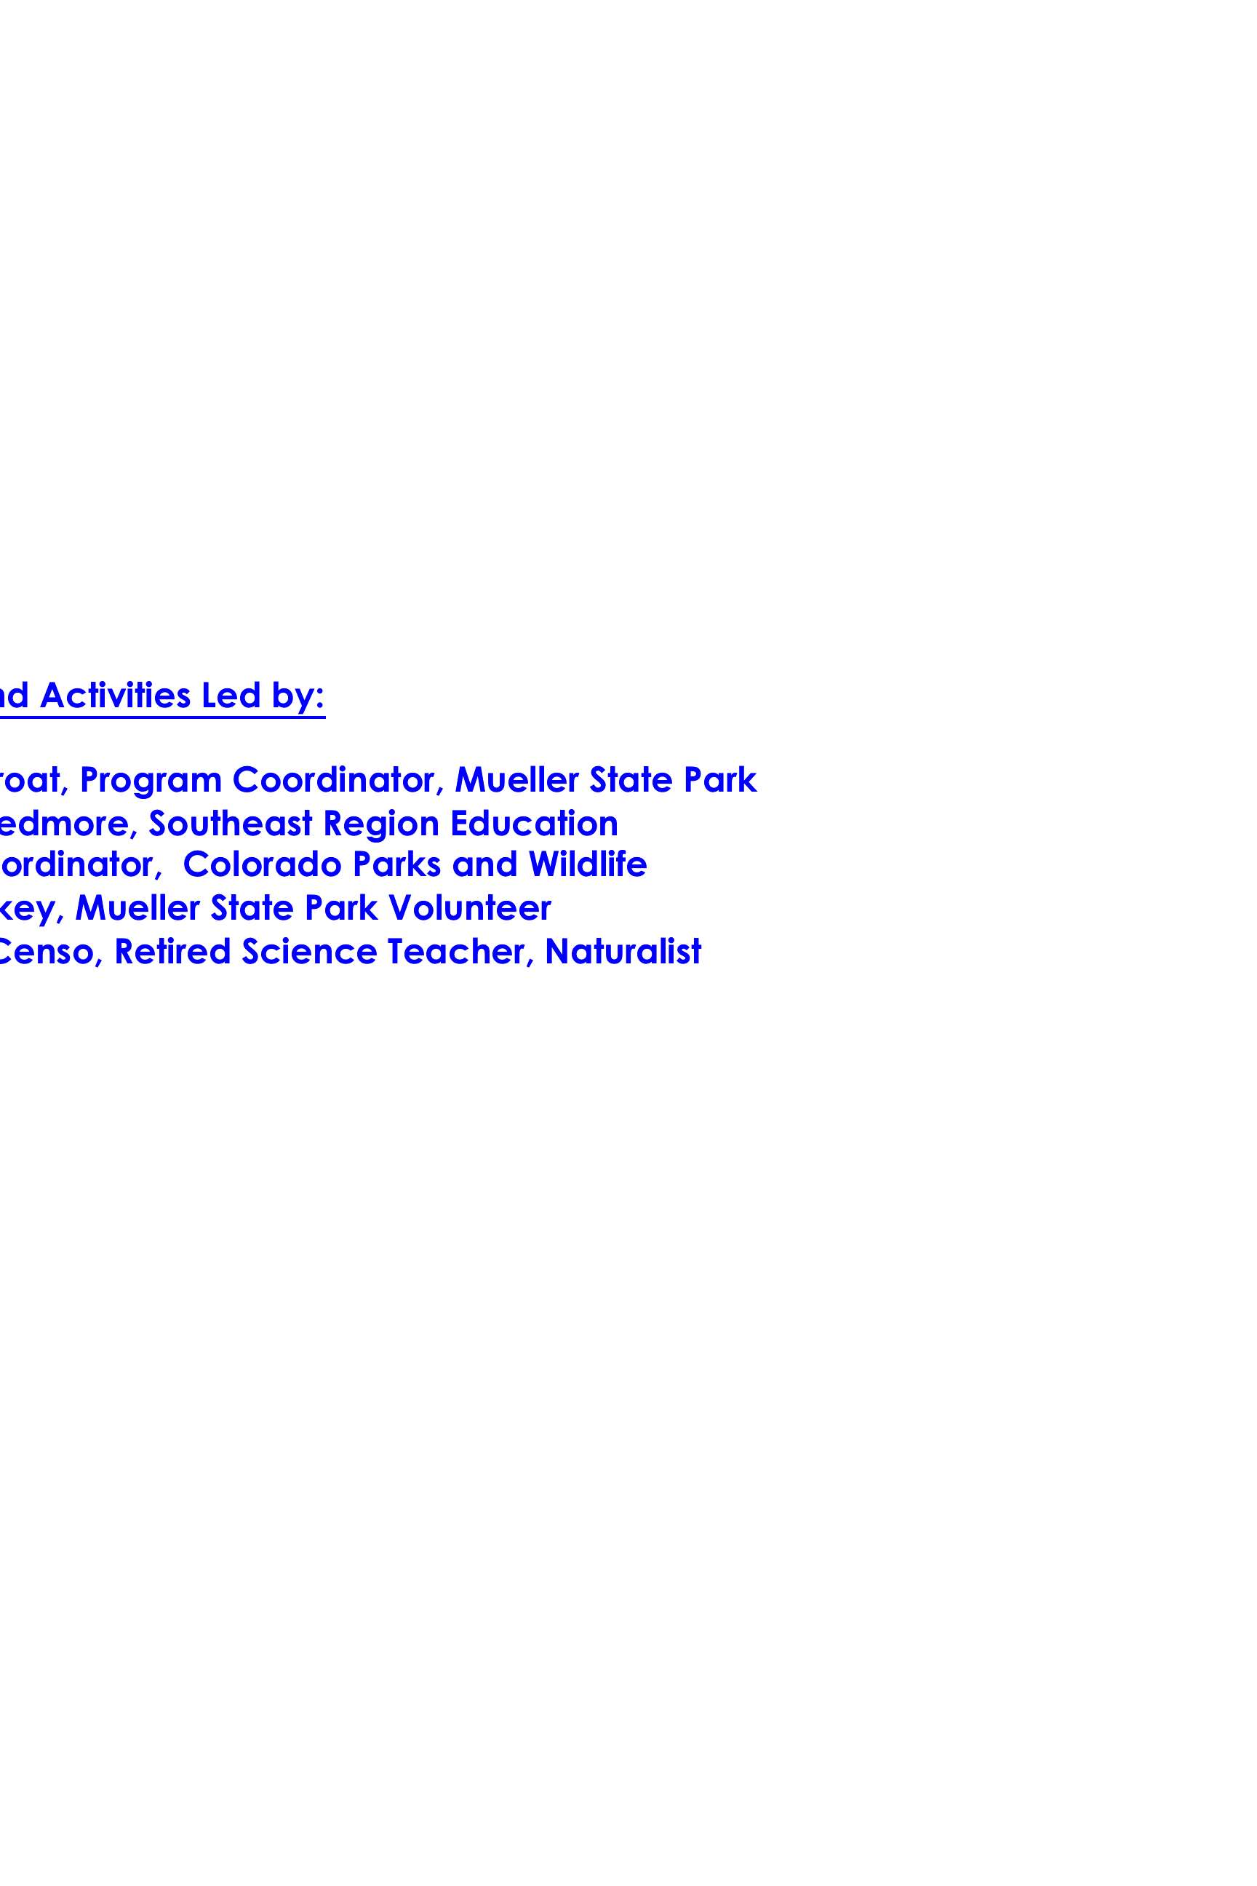

Marijuana and Youth

Wednesday, October 7th, 2015
Sand Creek High School 4 p.m. to 8 p.m.
Brought to you by Peak Area Leadership in Science (ww.scienchubs.org)

AGENDA:

4:00 – 4:30 Networking, Refreshments
4:30 – 4:40 Introductions, Logistics
4:40 – 5:40 Speaker 1: Lisa Barker, MPH, Marijuana Program Manager,
Environmental Epidemiology, Occupational Health, and Toxicology Section
Colorado Department of Public Health and Environment

Lisa, an epidemiologist will address the science and research around marijuana use. The epidemiologist will talk about how marijuana effects the body/brain.... particularly looking at youth... and will highlight the research that has been collected and reviewed by a panel of 13 experts in the medical field.
5:40 – 5:50 Short Break
5:50 – 6:50 Speaker 2: Erin C. Flynn, MPH, Marijuana Education and Youth Prevention Coordinator, Colorado Department of Public Health and Environment
P: 303.692.6435 | 4300 Cherry Creek Drive South, Denver, CO 80246
erin.flynn@state.co.us | www.colorado.gov/cdphe

Erin will talk about the prevention aspects of marijuana and youth... and will share some resources for professionals working with youth.

6:50 – 7:50 Speaker 3: Catharine Beecher, MD, LPC.
"How does marijuana affect a teen's brain?" addressing…
- Basic anatomy and functions of the brain - particularly those regions most impacted by marijuana
- How messages are relayed in the brain/neurotransmission - and how it is impacted by marijuana
- What is the 'reward pathway' - and particular issues for young marijuana users
- When the risk/reward balance may tip towards using marijuana, e.g. in treatment of seizure disorders

7:50 – 8:00 Final Questions and Evaluation

Resources distributed by PALS on October 7th (in Pink Folder)

Please contact ssmith4660@gmail.com if you have any additional resources you would like to see listed .

- From Colorado Department of Public Health and Environment:

https://www.colorado.gov/cdphe/retail-marijuana
and
https://www.colorado.gov/marijuana

You can order posters and factsheets on marijuana in color for free from www.cohealthresources.org
- Select "Begin a New Order"
- On the left-hand side select "Marijuana Resource Materials"
- As you scroll through the options, you will see all available factsheets.

Factsheets:
- Answers to Common Questions about Marijuana
- Retail Marijuana in Colorado: Health Effects
- Tips for Youth-Serving Professionals
- Youth and Marijuana
- Retail Marijuana: Methods of Use
Poster
- Good to Know Poster "Growing Brains" 16x20 Orange
- There are other ‘good to know’ posters… but this one seemed most applicable to tonight’s talks.

- From National Institute on Drug Abuse
http://www.drugabuse.gov/publications
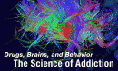
- Drugs, Brains, and Behavior: The Science of Addiction
Booklet - Published April 2007. Revised July 2014. Provides scientific information about the disease of drug addiction, including the many harmful consequences of drug abuse and the basic approaches that have been developed to prevent and treat the disease.

- Marijuana: Facts Parents Need to Know
Booklet - Published April 2001. Revised March 2014. Brochure, in question-and-answer format, that provides facts about marijuana for parents and offers tips for talking with their children about the drug and its potential harmful effect.

- Marijuana: Facts for Teens
Booklet - Published April 2001. Revised May 2015. Presented in question-and-answer format and targeted to teens, provides facts about marijuana and its potential harmful effects.
- POSTERS:
- Drugs + Your Body: It Isn’t Pretty (Teaching Guide) Poster
This poster/teaching guide includes an eye-catching poster, lesson, and dynamic worksheets designed to provide factual details and critical-thinking questions on the wide-ranging effects drugs have on the developing brain and body. These effects include harmful physical and psychological consequences that affect not only individuals, but also families, friends, and communities. (First published 2012)
- Heads Up: Drugs & the Body – It Isn’t Pretty: English / Spanish Poster
- Marijuana: Download the Facts Spanish & English Poster (this poster is not included in the pink folder, but one is on display)

- Heads Up – “Real News About Drugs and Your Body - You can order the student magazines (up to 30 of each issue) and a teachers guide. Available for years 14-15, 13-14, 12-13, and 10-11. We included the three most recent years (student and teacher copy) in your pink folder.

- Mind Over Matter: The Brain's Response to Marijuana – Revised August, 2014
- Note: There are many other pamphlets in this series… each addressing a different type of drug.

- BrainPower! Poster – From a curriculum series – We included one sample of the Grade 6-9 posters that come with the curriculum. One poster deals specifically with marijuana, one deals with the brain. More info on the next page.

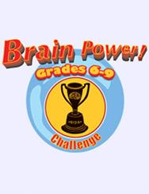
Resources available for viewing / door prizes on October 7th

1. BRAIN POWER CURRICULA – available through http://www.drugabuse.gov/publications

- Brain Power! Challenge Grade 6-9: Science-Based Drug Abuse Information for Students
- Brain Power! Challenge Posters Grade 6-9 (5 groups of 6 different posters in 1 set)

Offers an interactive science education program for students in grades 6–9 about the brain and the effects of drugs on the body. Includes six modules, a teacher’s guide, a parent newsletter, and a CD-Rom. You can also order a poster set providing additional copies of the posters that are integral to the curriculum. March 2007

- Brain Power! The NIDA Junior Scientist Prog: Grades 4-5 DVD

Offers an interactive science education program for students in grades 4–5 to explore the human brain and the effects of drugs on the brain. Includes six modules, a teacher’s guide, parent newsletter, poster, and DVD for Mac computers. Online videos available for other devices.

- Brain Power! The NIDA Junior Scientist Prog: Grades 2-3 DVD

Provides a science program for students in grades 2–3 to educate on their brains, why they should protect them, and how drugs such as nicotine and inhalants can be of harm. Includes six modules, a teacher’s guide, a parent’s guide, and a DVD for Mac computers. Online videos available for other devices.

- Brain Power! The NIDA Junior Scientist Program Posters: Grades K-1

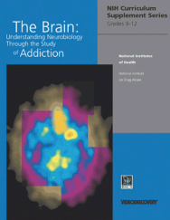
Offers supplemental posters to an interactive science education program for students in grades K–1 about scientists, the brain, the nervous system, and the effects of drugs on the human body.

- The Brain: Understanding Neurobiology Through the Study of Addiction - – available through http://www.drugabuse.gov/publications
Equips teachers and students in grades 9 through 12 with interactive curriculum on the neurobiology of the brain as a result of drug abuse and addiction. March 2010
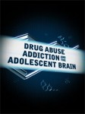
- DRUG ABUSE, ADDICTION, AND THE ADOLESCENT BRAIN This DVD and 120-page book is a unique and informative new curriculum supplement designed for middle school science classes. The program features five classroom lessons that focus on the science of how drugs affect the brain; an integrated video with interviews by leading scientists in the area of drug abuse research, treatment experts, and recovering drug addicts; animations to illustrate the effects of drugs; and a facilitation guide for presenting the video to adult audiences. Funded by the National Institute of Drug Abuse (NIDA). http://www.bscs.org/estore/drug-abuse-addiction-and-adolescent-brain
ADDITIONAL RESOURCES - Marijuana and Youth
Focused on the research / data:

- Scientific literature review of marijuana-related health effects

https://www.colorado.gov/pacific/cdphe/scientific-literature-review-marijuana-related-health-effects

Per CRS 25-1.5-110, the Retail Marijuana Public Health Advisory Committee was appointed to review the science of marijuana-related health effects. The committee is responsible for reviewing the current scientific literature, summarizing the evidence, and translating the evidence into public health statements and recommendations that everybody can understand. The link above takes you to the page that provides the full report* as well as subtopics**, including:

*https://drive.google.com/folderview?id=0BxqXhstk92DbfnNfSURHd0VFZjEtRFpsVEg3bjM5QUJXOEd0VWZDOUNjSnpWWEFvTVdiUFU&usp=sharing see pages 94-102

**2014 Marijuana Use Among Adolescents and Young Adults - Systematic Literature Review

Marijuana – Overview of the 2013 Data - The Healthy Kids Colorado Survey (HKCS)

http://www.ucdenver.edu/academics/colleges/PublicHealth/community/CEPEG/UnifYouth/Documents/Marijuana%20Overview.pdf

Marijuana – Overview of the 2013 Data - The Healthy Kids Colorado Survey (HKCS) collects self-reported health information from Colorado middle and high school students. A unified version of the survey was launched in 2013 that consolidates multiple needs for youth health data and allows for both state and regional-level results. The unified HKCS was administered in Fall 2013 to over 40,000 middle and high school students.
This summary outlines findings from the marijuana-related items included in the 2013 HKCS high school survey. The survey was primarily administered before retail marijuana sales went into effect.

ADDITIONAL ONLINE RESOURCES - Marijuana and Youth
Aimed towards Youth:

- ABOVE THE INFLUENCE - (Office of Natl Drug Control Policy) - Site for youth – addresses all types of influences – including marijuana – project of the Partnership for Drug Free Kids

http://abovetheinfluence.com/drugs/marijuana/#facts

http://abovetheinfluence.com/resources/

- DON’T BE A LAB RAT – This was a controversial marijuana education campaign in 2014 that was NOT used in Colorado.

- http://dontbealabrat.com
- http://www.wsj.com/articles/lab-rat-ads-warn-teens-of-pot-use-1412560470
- http://www.thedenverchannel.com/news/local-news/new-marijuana-education-campaign-in-colorado-wont-use-controversial-dont-be-a-lab-rat-slogan

- DRUG PREVENTION 4 TEENS (DEA, 2008) This guide presents information on drugs of abuse, including marijuana, the costs to society of adolescent drug use, attitudes about drugs, information about the legalization debate, and a guide to how teens can help prevent drug use and increase awareness about drugs for themselves and their peers.

http://www.dea.gov/pr/multimedia-library/publications/prevention4teens.pdf

- MEDLINE PLUS : MARIJUANA INFORMATION (NIH) - From the National Library of Medicine, overviews on what marijuana is and how it works, pictures and photos, and more.

https://www.nlm.nih.gov/medlineplus/marijuana.html

- NEUROSCIENCE FOR KIDS - was created for all students and teachers who would like to learn about the nervous system. Discover the exciting world of the brain, spinal cord, neurons and the senses. Use the experiments, activities and games to help you learn about the nervous system. Includes plenty of links to other web sites for students to explore.

https://faculty.washington.edu/chudler/neurok.html

- NIDA FOR TEENS – THE SCIENCE BEHIND DRUG ABUSE – Includes drug facts, health and drug blog, interactives and videos – addresses many abused drugs… including marijuana

http://teens.drugabuse.gov

- PROTECT WHAT’S NEXT: Site for Youth with videos, resources, health effects, consequences

http://protectwhatsnext.com

- THE SCIENCE OF ADDICTION – GENETICS AND THE BRAIN from Learn.Genetics – Genetics Learning Center University of Utah Health Sciences – site contains “learn more” and “interactive explore” components accessible to youth… many address the brain and some address drugs and the brain.

http://learn.genetics.utah.edu/content/addiction/

- http://learn.genetics.utah.edu/content/addiction/resources/

Note – This site does also have teacher materials and a list of valuable resources

- BRAIN ON DRUGS – THE SCIENCE OF DRUG RECEPTORS - The Why Files – the Science behind the News

http://whyfiles.org/225drug_receptors/

- THE BRAIN FROM TOP TO BOTTOM – An interactive web-site about the human brain and behavior – lots about the brain, a little about marijuana and the brain

http://thebrain.mcgill.ca/avance.php

ADDITIONAL RESOURCES - Marijuana and Youth
Aimed towards Professionals working with Youth (Teachers, etc) :

- *COLORADO DEPARTMENT OF EDUCATION DROPOUT PREVENTION RESOURCES - Resources that may be helpful to educate school staff, students, parents, and the broader public about the dangers of substance abuse. Information includes how using drugs may impede learning and undermine student achievement. Formats include brochures, fact sheets, slides

http://www.cde.state.co.us/dropoutprevention/resources

- GET SMART ABOUT DRUGS – A DEA resource for parents, educators, and caregivers.

http://getsmartaboutdrugs.com

http://www.dea.gov/docs/drugs_of_abuse_2011.pdf

- LEARN ABOUT MARIJUANA – SCIENCE BASED INFORMATION FOR THE PUBLIC - Alcohol and Drug Abuse Institute, University of Washington

http://learnaboutmarijuanawa.org

- MARIJUANA – BREAKING DOWN THE BUZZ –

"Marijuana: Breaking Down the Buzz" First published 2014
Amid changing marijuana laws, surveys of teens nationwide show an increasing perception that marijuana is safe. But the fact is, marijuana use can have serious short- and long-term consequences for the developing teen brain. The teaching resources (provided at the url ) below highlight crucial scientific facts on the risks of marijuana, while challenging students to apply skills in reading comprehension and critical thinking to informational texts.

http://headsup.scholastic.com/teachers/lesson-marijuana-breaking-down-the-buzz

note: scholastic has other resources that address marijuana and youth.

http://headsup.scholastic.com/teachers/

- *MARIJUANA IN COLORADO – GOOD TO KNOW – Created to provide statewide current information for the general public on the data and health effects of marijuana and retail marijuana laws. The information available here will continually expand to feature a Spanish language version of the site, newly released data and public awareness campaigns to inform Coloradans.

https://www.colorado.gov/pacific/marijuana

- https://www.colorado.gov/pacific/marijuana/laws-and-youth
- https://www.colorado.gov/pacific/marijuana/effects-youth
- https://www.colorado.gov/pacific/marijuana/working-youth
- https://www.colorado.gov/pacific/marijuana/news/youth-marijuana-education-campaign

- *MARIJUANA IN COLORADO - GOOD TO KNOW - Site for adults to help young people make good decisions through open conversation about underage marijuana use and its effects.

http://goodtoknowcolorado.com/talk/

- NATIONAL INSTITUTE ON DRUG ABUSE - Comprehensive site that addresses multiple aspects of drug abuse, significant and current information on marijuana including ‘drugfacts’, recent findings, news, publications available to download or request free copies… and more.

http://www.drugabuse.gov/
- Messages from the Director - Marijuanas Lasting Effects on the Brain and Challenging Marijuana Myths
  - http://www.drugabuse.gov/about-nida/directors-page/messages-director/2012/09/marijuanas-lasting-effects-brain
  - http://www.drugabuse.gov/about-nida/directors-page/messages-director/2013/02/challenging-marijuana-myths
- http://www.drugabuse.gov/publications - free publications including brochures, posters, podcasts, curriculum

- NIDA FOR TEENS – THE SCIENCE BEHIND DRUG ABUSE – Includes NIDA teaching guides, lessons and quizzes by drugs, statistics and infographics, brush up on your science, national drug and alcohol facts week (January 25-31, 2016), how to order free materials

http://teens.drugabuse.gov/educators

- *SPEAK NOW is an effort of the Colorado Department of Human Services, Office of Behavioral Health focused on providing evidence-based information and resources to parents and caregivers regarding youth substance abuse prevention in Colorado. Speak Now addresses the use of alcohol and drugs among Colorado's youth. It's an educational resource for parents and caregivers on how to keep conversations going about the risks of alcohol and drug use among youth. Includes parent info, community resources, Fact Zone, videos…

http://speaknowcolorado.org

- THE SCIENCE OF ADDICTION – GENETICS AND THE BRAIN from Learn.Genetics – Genetics Learning Center University of Utah Health Sciences – site contains curriuculum modules for teachers.

Curriculum Module: The New Science of Addiction: Genetics and the Brain
http://teach.genetics.utah.edu/content/addiction/

Note – This site does also have student materials including “learn more” and “interactive explore” components accessible to youth.

http://learn.genetics.utah.edu/content/addiction/ http://learn.genetics.utah.edu/content/addiction/resources/

- THE TEEN BRAIN – STILL UNDER CONSTRUCTION
Discusses research findings on how the brain changes and matures during adolescence. Reminds parents that the ups and downs of the teen years often are related to these changes. Points out teens' higher risk from alcohol use at this stage. Lists resources, and notes future directions for research. Allows you to download an electronic version.

https://infocenter.nimh.nih.gov/nimh/product/The-Teen-Brain-Still-Under-Construction/NIH%2011-4929

- MIND UP – is a research-based curriculum that features 15 lessons that use the latest information about the brain to dramatically improve behavior and learning for all students.
They have posters titled “Getting to Know and Love your Brain” appropriate for 3 different grade levels. There is a cost for this resource.

http://teacher.scholastic.com/products/mindup/

